Blue-Team Proof of Concept
Registry-Mediated Installer Metadata Tampering and Module-Load Detection
Defensive Research White Paper • POC-01 • Version 1.0
This proof of concept evaluates a defensive hypothesis: whether manipulation of GPU/driver installer metadata could precede an unintended module-loading condition in a privileged Windows process, and whether defenders can reliably detect and reconstruct the sequence. It intentionally avoids operational persistence, concealment, privilege escalation, pre-OS payloads, and instructions for weaponized DLL hijacking.

Executive Summary
The observed registry location is HKLM\SOFTWARE\NVIDIA Corporation\Installer2\Extensions. The supplied screenshot shows package records for Display.Driver, Display.PhysX, FrameViewSdk, HDAudio.Driver, and ShadowPlay, with data pointing into NVIDIA Installer2 package directories. These entries are evidence of installer/package metadata; they are not, by themselves, evidence that the GPU loads a DLL, that NVIDIA is vulnerable, or that code executes before Windows.
The POC uses a surrogate registry hierarchy that mirrors the shape and data types of the observed metadata. A controlled laboratory consumer reads a modified value and generates a harmless marker event representing a module-load condition. Telemetry is retained across the complete sequence: baseline → metadata mutation → consumer access → benign marker → value restoration. The goal is to prove or falsify detection coverage, not to create persistence.

1. Source Observation
The screenshot establishes a useful baseline for the research question. It shows the Installer2\Extensions key and multiple REG_MULTI_SZ extension/package entries. The image does not establish how each value is consumed internally.
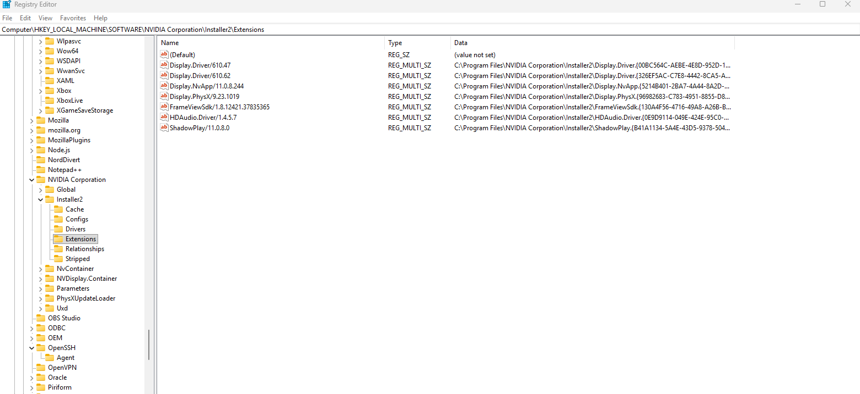
Figure 1. User-supplied Registry Editor view of NVIDIA Installer2\Extensions.

2. Hypotheses
- H1 — A privileged installer/service that consumes mutable package metadata could create an unsafe module-loading opportunity if path, ACL, or signature validation is insufficient.
- H2 — A rapid modify → consume → restore sequence can be detected even when the final registry state matches the original baseline.
- H3 — Code Integrity, application control, signature/catalog verification, and writable-path controls can prevent or elevate the simulated condition.
- H4 — A claim of genuinely pre-OS execution requires separate UEFI/boot/early-driver evidence and cannot be inferred from Installer2 metadata.

3. Threat Model and Boundaries
Element | Laboratory model | Boundary
Initial capability | Authorized administrator in disposable VM | Initial compromise is not modeled
Registry target | Surrogate key mirroring Installer2 metadata | Do not modify production package records
Consumer | Purpose-built lab harness | No impersonation of a real NVIDIA binary
Execution marker | Harmless local marker/module | No persistence, injection, network callback, or evasion
Cleanup | Restore original surrogate value | Restoration is measured, not hidden
Pre-OS | Separate forensic workstream | No firmware or boot-chain modification

4. Laboratory Architecture
Run the experiment in a disposable Windows virtual machine with a clean snapshot. Create a surrogate registry tree under a laboratory-owned namespace with values that resemble the observed REG_MULTI_SZ path metadata. The controlled consumer reads only that surrogate data. The benign marker should perform no action beyond generating an attributable local event or log record.
Experiment sequence: snapshot → baseline collection → surrogate value change → controlled read → benign marker → restore value → preserve logs → revert VM.

5. Telemetry Collection Plan
- Registry: value set/create/delete/rename/restore events, including old and new values where supported.
- Process: process creation, parent/child relationship, command line, integrity level, signer, and hashes.
- Image/module load: process, module path, hash, publisher/catalog state, and source directory.
- Filesystem: creation, rename, and deletion of laboratory artifacts; retain NTFS USN evidence where available.
- Code integrity/application control: WDAC, AppLocker, Defender, and Windows Code Integrity events relevant to trust decisions.
- Time correlation: normalize timestamps to UTC and assign an experiment/run identifier to laboratory-generated logs.

6. Detection Analytic
The primary analytic is temporal correlation. Alert when protected installer or driver-package metadata changes and is followed within a short interval by activity from a related privileged consumer, an unexpected image load or child process, and optional restoration of the modified value. The restoration event should increase—not reduce—interest because it can indicate an attempt to return the endpoint to a benign-looking final state.
Risk scoring should increase for unsigned or unexpectedly signed modules, modules outside the expected package directory, user-writable source locations, catalog/hash mismatches, unusual parent/child relationships, and repeated change-and-restore cycles.

7. Test Matrix
Test | Condition | Expected telemetry | Pass criterion
T1 | Baseline; no mutation | Normal registry/process activity | Known-good profile established
T2 | Surrogate registry mutation | Registry event | Mutation and actor recorded
T3 | Controlled consumer reads value | Process + lab log | Read correlated to mutation
T4 | Benign marker event | Image/process/local marker | Marker attributed to consumer
T5 | Value restored | Registry restoration | Full chain remains reconstructable
T6 | Nontrusted benign test module | Code Integrity/application-control event | Block or high-severity detection
T7 | Surrogate points to lab writable path | Path + module telemetry | Writable-path condition detected

8. Success and Falsification Criteria
Success means the blue team can reconstruct the complete sequence from independent telemetry and can distinguish a transient metadata change from ordinary installer activity. Preventative-control success means the simulated untrusted condition is blocked before the benign marker is accepted as a trusted module event.
The NVIDIA-specific hypothesis is not supported if the real Installer2 values are not consumed as executable/module paths, if package/catalog validation makes substitution ineffective, or if they are purely bookkeeping. A successful surrogate experiment validates detection engineering only; it does not demonstrate an NVIDIA vulnerability.

9. Separate Pre-OS Investigation
The proposition that execution occurs before the normal OS initializes belongs to a different trust boundary. Investigate Secure Boot state, UEFI variables, firmware and option-ROM provenance, boot manager integrity, early-launch/early-boot driver signatures, TPM measurements where available, and offline comparison with known-good boot artifacts. Installer2 registry metadata alone cannot establish pre-OS persistence.

10. Evidence Preservation
Before each run, preserve the VM snapshot, registry baseline, relevant binary hashes/signatures, sensor configuration, and system time source. After each run, export event logs and laboratory logs before reverting. Keep original evidence read-only and maintain a simple chain-of-custody record containing artifact name, SHA-256, collection time, source, and collector.

11. Defensive Outcomes
The desired product is a durable detection rule for transient installer-metadata tampering, supported by enough independent telemetry that restoration of the final registry state cannot erase the history. A secondary outcome is a clear decision tree separating ordinary installer bookkeeping, unsafe post-boot module loading, and genuinely pre-OS anomalies.

12. Conclusion
Registry-mediated installer metadata poisoning is a reasonable blue-team hypothesis to test, but it should be evaluated without assuming the suspected consumer behavior. This POC isolates the measurable claim and provides explicit falsification criteria. If the hypothesis survives laboratory testing, the next step is controlled validation of the real consumer and, where appropriate, responsible disclosure. If it fails, the resulting telemetry baseline is still valuable because it defines what legitimate Installer2 activity looks like.
Classification: Defensive Security Research / Authorized Laboratory Use

